OCL ART 100
Module 5: Meaning

“There is only one thing in a work of art that is important: it’s that thing you can’t explain”.
Georges Braque

Even though Braque’s enigmatic quote cloaks works of art in mystery, art, by its nature, holds meaning. It explains ideas, uncovers truths, manifests what is beautiful and tells stories. It is at once a form of visual expression and non-verbal communication. Many times an artwork’s meaning, or content, is easy to see. Two examples are the freshness of an Impressionist landscape painting or the identity inherent in a portrait photograph. But sometimes the meaning in a work of art is hidden, deciphered from signposts and clues imbedded in the work by the artist. In this module we will see how formal properties, subject matter, iconography and context team up to help interpret meaning in art. Let’s approach these four terms as different levels of meaning we can examine to get a more complete understanding of what we are seeing.

The First Level of Meaning: Formal

We’ve been looking at artworks through the most immediate of visual effects; formal analysis let’s us take stock of what we have in front of us. Looking, however, is different than seeing. To look is to get an overview of your field of vision. Seeing speaks more to understanding. When we use the term “I see” we communicate that we understand what something means. With art, this may at first appear to be simple: separate out each element and discover how it is used in the work. Actually, there are some areas of learning that have looked at this very closely: particularly psychology and biology. In these areas, the fact that humans perceive flat images as having a "reality" to them is very particular. In contrast, if you show a dog an image of another dog, they neither growl nor wag their tail, because they are unable to perceive flat images as containing any meaning. So you and I have actually developed to be able to "see" images. In addition, there is a cultural component in how we perceive images.

For example, when many of us from industrialized cultures see a parking lot, we can pick out each car immediately, while others from remote tribal cultures (who are not familiar with parking lots) cannot. Gestalt is the term we use to explain how the brain forms a whole image from many component parts. For instance, the understanding of gestalt is in part a way to explain how we have learned to recognize outlines as contours of a solid shape, allowing us to draw "space" using only lines.

The sites below have some fun perceptual games from psychology and science about how we see along with some further explanations of gestalt:

http://www.scientificpsychic.com/graphics/

http://dragon.uml.edu/psych/illusion.html

So after we see the object, we can understand how it is "made": its form. With every mark the artist's hand makes, we see how quickly, which direction, what kind of energy it leaves. In fact, when we begin discussing history you will see that there is a big difference between work in which the artist's hand is visible and work that is purely gestural; that is, abstract or non-objective work where the focus is on the application of the medium to the artwork. Often we have trouble with the purely gestural, because this contradicts ideas we have about skill and talent. Also, the invention of the photograph has greatly changed our ideas about what looks correct. A good example of this idea can be seen looking at the two images in Module 5’s Image file; the first is a digital photo of a foggy landscape that I took, and the second, a painting by the Abstract Expressionist painter Mark Rothko. When you compare the two, you see that formally they are similar; bands of complementary color spread horizontally across the surface in layers. Yet Rothko’s painting is much more reductive than the photo. The space is flat, sitting right on the surface of the canvas, whereas in the photo you get a feeling of receding space as areas of color overlap each other. This similarity is not coincidental. As a young man Rothko lived for in Portland, Oregon, and hiked the Cascade Mountains. On hikes to higher elevations, he saw the landscape and atmosphere around him and was especially moved by the colors in the sky near the horizon just before sunrise and just after sunset. This phenomenon is called the Veil of Venus: bands of pink, violet and blue near the horizon directly opposite the setting or rising sun. You can see a good example in Module 5’s Image File. Now you can imagine these memories reflected in Rothko’s series of abstract ‘color field’ paintings. It’s simplistic to say this was Rothko’s only influence. As an artist he explored painting styles emerging out of Surrealism, including automatic drawing and more complex mythomorphic techniques. But it’s hard to deny that to some extent his paintings are based on what he saw. Click the link to read more about Mark Rothko.

Early photographs were actually made to look like paintings, including scratching and painting over their surface, because the perfection of the photographic image was considered too perfect and mechanical. We can see this in a comparison of a nineteenth century photo of the Acropolis in Athens, Greece, and a painting from the series ‘The Course of Empire’ by Thomas Cole titled “The Consummation”. Both show a commanding view of a classical landscape. Conversely, realist paintings from the 19th century were sometimes ridiculed for being too lifelike but not ‘ideal’ enough. Theodore Gericault’s Raft of the Medusa is an example. You can click to enlarge the image and read “A Hint of Scandal” to the right of it to why such a realistic, powerful painting could be caught up in controversy. Nowadays people often proclaim that a painting is good because it looks "just like a photograph".

The rise of modern art produced artistic styles that challenge viewers in finding meaning in the works they see. The use of abstraction and gesture as subject matter runs counter to traditional avenues for finding meaning. It is in this gestural approach, however, that much of the grace and delicacy, as well as power, anger or other emotions can be conveyed. In other words, it is the application of the elements that can give us clues to a work’s meaning. If we then take the formal quality of application (what kind of line, how the paint is applied, etc) and combine it with a specific subject you can discover a meaning from the combination of these visual effects.

When looked at from this perspective, the paintings of the Abstract Expressionists become more meaningful. In particular, the art Joan Mitchell captures the exuberance and energy that the application of paint can achieve (see Formalist Criticism below).

This bridge between formal quality and subject matter can be applied to meaning in works of art from many cultures. Gesture and pattern combine to enhance the meaning of more decorative works like the paintings from a Ceremonial House ceiling from the Sepik region of New Guinea. The ceremonial house was built as a place for spirits to dwell. The paintings themselves indicate abstracted images of faces making fierce gestures, suns and female genitalia, all in reference to the spirits surrounding the ceremony taking place inside.

Second Level of Meaning: Subject

There are specific categories of ideas that people recreate that have been represented in art over time. These ideas, however, change over time. Many of them are present in some cultures, but never present in others. This disparity gives us another place to look for meaning when we approach differences in representation. But generally these categories of ideas (sometimes called subjects) can also be called a genre of art; that is, a fairly loose category of images that share the same content. Here is a brief list of the type of genre that you may see in a work:

landscape
still life
portrait
self-portrait
allegory: representing a mythological scene or story
historical: actual representation of a historic event
religious: two forms: religious representation or religious action
daily life: sometimes also called genre painting
nude: male nude and female nude are separate categories
political: two forms: propaganda and criticism
social: work created to support a specific social cause
power: work created to connect to specific spiritual powers
fantasy: work created to invent new visual worlds
decoration: work created to embellish surroundings
abstraction: work whose elements and principles are manipulated to alter the subject in some way.

What you will discover when you think about some of these subjects is that you may already have a vision of how this subject should appear. For example: visualize a portrait or self-portrait. You can see the head, probably from the shoulders up, with little background, painted fairly accurately. Look at the portrait links I have included below and see that this is moderately true; though some works may change and surprise you in this way.

Contemporary artists sometimes reinterpret artworks from the past. This can change the context of the work (the historical or cultural background in which the original work was created), but the content remains the same. Dorothea Lange’s Migrant Mother, Nipomo Valley from 1936 uses the subject matter of a mother and her children to symbolize the hardships faced during the Great Depression. The woman’s face speaks of worry and desperation about how to provide for her children and herself. San Francisco photographer Jim Thirtyacre’s image from 2009 reflects this same sentiment in a way that relates to a contemporary working mother who has become a victim of the current economic crisis (view his digital image “Working Mother” in the Image File of the same name in module 5’s content list).

It is also important to note that many cultures do not use particular genre in their art. For some cultures the representation of an actual human face is dangerous and can call up spirits who will want to live in the image: so their masks are extremely stylized while still face-like.

As we explore the themes selected for this course, you will see how the subject categories change over time, over cultures, and how their meaning changes.

Third Level of Meaning: Iconography

At the simplest of levels, iconography is the containment of deeper meanings in simple representations. It makes use of symbolism to generate narrative, which in turn develops a work’s meaning.

Each of the objects in this painting has a specific meaning beyond their imagery here. In fact, this painting is actually a painted marriage contract designed to solidify the agreement between these two families. It is especially important to remember that this is not a painting of an actual scene, but a constructed image to say specific things.

- You notice that the bride is pregnant. She wasn't at the time of the painting but this is a symbolic act to represent that she will become fruitful.
- The little dog at her feet is a symbol of fidelity, and is often seen with portraits of women paid for by their husbands.
- The discarded shoes are often a symbol of the sanctity of marriage.
- The single candle lit in the daylight (look at the chandelier) is a symbol of the bridal candle, a devotional candle that was to burn all night the first night of the marriage.
- The chair back has a carving of St. Margaret, the patron saint of childbirth.
- The orange on the windowsill and the rich clothing are symbols of future material wealth (in 1434 oranges were hand carried from India and very expensive).
- The circular mirror at the back reflects both the artist and another man, and the artist's signature says "Jan van Eyck was present", both examples of witnesses for the betrothal pictured. (We don't think of this much anymore, but a promise to marry was a legal contract). The circular forms around the mirror are tiny paintings of the Stations of the Cross.

For another similar discussion of iconography in art, view and listen to art historians talk about Robert Campin’s Renaissance-era painting, the Merode Alterpiece.

You can see how densely populated iconography in imagery can convey specific hidden meanings. The problem here is to know what all of this means if we want to understand the work. Another more contemporary painting with many icons imbedded in it is Grant Wood’s American Gothic from the 1930’s. The dower expressions on the figures’ faces signify the toughness of a Midwestern American farm couple. Indeed, one critic complained that the woman in the painting had a “face that could sour milk”. Notice how the trees and bushes in the painting’s background and the small cameo the woman wears mirror the soft roundness of her face: these traditional symbols of femininity carry throughout the work. In contrast, the man’s straight-backed stance is reflected in the pitchfork he holds, and again in the window frames on the house behind him. Even the stitching on his overalls mimics the form of the pitchfork. The arched window frame at the top center of the painting in particular is a symbol of the gothic architecture style from 12th century Europe.

In addition, a popular genre in painting from 16th century northern Europe, especially the Netherlands, is known as vanitas painting. These still life paintings are heavily dependant upon symbolic objects that project the joy and accomplishments life affords us, yet at the same time remind us of our mortality. Edward Collier’s painting below is a good example of how crowded these could be.
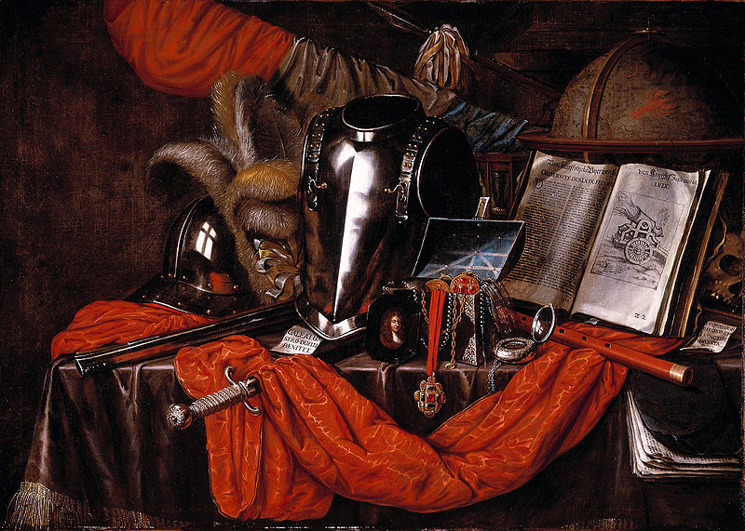
The armor, weapons and medals show a focus on military accomplishments. The open book alludes to knowledge and in this case, the drawing of a canon mirrors the overall theme. The globe is a symbol of both travel and our common existence as earth-bound beings. Contemporary vanitas paintings could certainly include allusions to air and space travel. On the far right of the work, behind the book and in the shadows, lies a skull, again reminding us of the shortness of life and the inevitability of death.
We can use iconography to find meaning in artworks from popular culture too. The “Golden Arches” mean fast food, the silhouette of an apple (with a bite out of it) means a brand of computer, a single, sequined glove stands for Michael Jackson, the ‘king of pop’ and the artist Andy Warhol’s soup can image forever links Campbell’s soup with Pop Art.
The craft arts have meaning too, primarily in the functionality of the art works themselves, but also in the style and decorations afforded them. A goblet from the 16th century has an aesthetic meaning in its organic form, in its function as a means to hold and dispense liquid, and a particular meaning in the way it is embellished with diamond point engravings that depict the flow of the river Rhine (click ‘zoom’ at the bottom of the image to see the goblet in detail).

The Fourth Level of Meaning: Context
The goblet’s detailed map of the Rhine gives it specific context: the historical, religious or social issues surrounding a work of art. These issues not only influence the way the viewer finds meaning in particular works of art but also how the artists themselves create them. For instance, the hammered gold mask from Peru’s Sican culture below is simple and symmetrical in form and striking in its visage. For the Sican people the mask represented either the Sican deity from the spiritual world or the lord of Sican, a man who represented the deity in the natural world. Masks were stacked at the feet of the dead lord in his tomb. In this cultural context the masks had significance in the life, death and spiritual worlds of the Sican people.
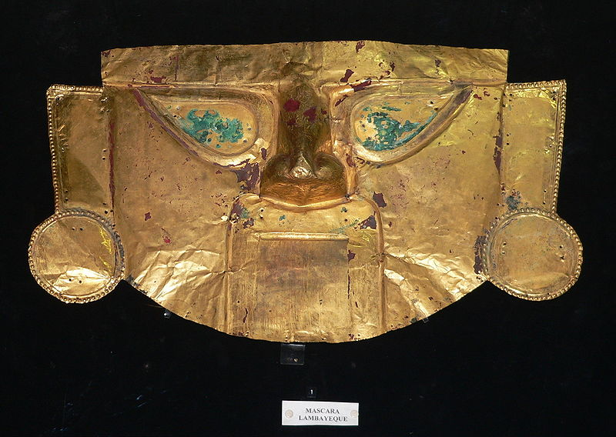
Golden Mask, Lambayeque, Sican culture, Peru. C. 9th century C.E.
Museo Oro del Peru y Armas del Mundo, Lima.
To view James Rosenquist’s painting F-111 is to be confronted with a huge image of a fighter jet overlaid with images from popular culture, all in bright colors and seemingly without connection. But when we see the work in the context of American experience in the 1960’s we realize the two-pronged visual comment Rosenquist is making about war and consumerism; what he termed “a lack of ethical responsibility”*. In the artist’s hands the two ideas literally overlap each other: the salon hair dryer and diver’s bubbles mimic the mushroom cloud rising behind the opened umbrella (which is another formal link to the nuclear bomb blast behind it). The painting is at such a large scale that viewers are dwarfed by its overpowering presence.
*James Rosenquist, “Painting Below Zero”, Notes on a Life in Art, 2009, Alfred A. Knopf, page 154.

Critical Perspectives

From the first forms of art criticism in ancient Greece, the discussion of meaning in art has taken many directions. As we realized in module 2, the professional art critic is one of the gatekeepers who, through their writing, endorse or reject particular kinds of art, whether in style, artistic ability or message. In fact, a study of the different ways to look at art can tell us much about changing times and philosophies: the role of aesthetics, economics and other cultural issues have much to do with the origin of these philosophical positions. Of course, none of them are completely true but simply different types of discourse. People approach meaning from different perspectives. The artworks sit silent while all around them the voices change. We are at a time when there are several, sometimes greatly conflicting, ways of thinking about meaning in art. Here are six different perspectives art critics use as compasses to interpreting meaning:

Structural Criticism: We started this course with a discussion of what art is. That discussion was actually based on one of the ways to look at art: what is known as structuralism. Structuralism is based on the notion that our concept of reality is expressed through language and related systems of communication. On a larger scale, visualize culture as a structure whose foundation is language, speech and other forms of communication. When this approach is applied to the visual arts, the world of art becomes a collective human construction, where a single work needs to be judged within the framework supported by the whole structure of art. This structure is still based in language and knowledge and how we communicate ideas. I often use the example of the word "cowboy".

In your head: visualize a cowboy: then describe what you saw. What gender was your person? What race was this person? Now let’s apply those answers to historical fact. The fact is upwards of 60% of the historical cowboys in the United States were black slaves freed after the civil war. Did you see your cowboy as white?

Your idea of cowboy might have come from film, which is an extremely different form of reality. The structural idea manifests itself when we look for meaning in art based on any preconceived ideas about it we already have in our mind. These preconceptions (or limitations) are shaped by language, social interaction and other cultural experiences.

Deconstructive Criticism goes one step further, and posits that any work of art can have many meanings attached to it, none of which are limited by a particular language or experience outside the work itself. In other words, the critic must reveal (deconstruct) the structured world in order to knock out any underpinnings of stereotypes, preconceptions or myths that get in the way of true meaning. Taking the perspective of a deconstructive critic, we would view a portrait of Marilyn Monroe by pop artist Andy Warhol as an imaginary construct of what is real. As a popular culture icon, Marilyn Monroe the movie star was ubiquitous: in film, magazines, television and photographs. Marilyn Monroe the person committed suicide in 1962 at the height of her stardom. In truth, the bright lights and celebrity of her Hollywood persona eclipsed the real Marilyn, someone who was troubled, confused and alone. Warhol’s many portraits of her –each one made from the same publicity photograph –perpetuate the myth and cult of celebrity.

Formalist criticism is what we engaged in when we looked at the elements and principles of art. Formalism doesn't really care about what goes on outside the actual space of the work, but finds meaning in its use of materials. One of the champions of the formalist approach was Clement Greenberg. His writing stresses “medium specificity”: the notion there is inherent meaning in the way materials are used to create the artwork. As is relates to painting and works on paper, the result is a focus on the two-dimensional surface. This is contrary to its traditional use as a platform for the illusion of depth. Formalism allows a more reasoned discussion of abstract and nonrepresentational art because we can approach them on their own terms, where the subject matter becomes the medium instead of something it represents. This is a good way to approach artworks from cultures we are not familiar with, though it has the tendency to make them purely decorative and devalue any deeper meaning. It also allows a kind of training in visual seeing, so it is still used in all studio arts and art appreciation courses.

Greenberg was a strong defender of the Abstract Expressionist style of painting that developed in the United States after World War 2. He referred to it as “pure painting” because of its insistence on the act of painting, eventually releasing it from its ties to representation.

Ideological criticism is most concerned with the relationship between art and structures of power. It infers that art is embedded in a social, economic and political structure that determines its final meaning. Born of the writings of Karl Marx, ideological criticism translates art and artifacts as symbols that reflect political ideals and reinforce one version of reality over another. A literal example of this perspective would view the Lincoln Memorial in Washington, D.C. as a testament to a political system that oppressed people because of race yet summoned the political will to set them free in the process of ending a Civil War.
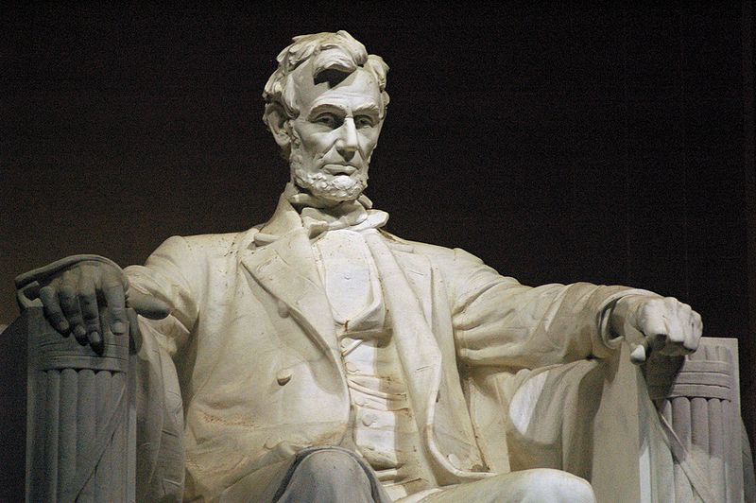
Statue of Abraham Lincoln, The Lincoln Memorial, Washington, D.C.
Photo by Jeff Kubina and licensed through Creative Commons.

In contrast, the painting “Canyon” by Helen Frankenthaler from 1965 could be considered a symbol of artistic (hence, political) freedom. The abstract Canyon was created in the United States at a time when much of the world was locked in a Cold War that pitted communism against democracy.

Psychoanalytic criticism is the way we should look at work if we feel it is only about personal expression. The purest form of this criticism ranks the work of untrained and mentally ill artists as being just as important as any other art. It is in this way that the artist “inside” is more important than any other reason the art happens or the effect the art has. Often when discussing Vincent van Gogh you will hear people discuss his mental state more than his actual artwork, experience, or career. This is a good example of psychoanalytic criticism. One of the problems in this type of criticism is that the critic is usually discussing issues the artist themselves may be totally unaware of (and may deny these issues exist).

Feminist criticism came in the 1970's as a response to the neglect of women artists over time and in historical writings. It is still interesting to note that some texts I have read actually state that women were not successful artists in history (check out Artemisia Gentileschi or Elizabeth Vigee Lebrun as examples of the silliness of this statement). This form of criticism is specific to viewing art as an example of gender bias in historical western European culture and views all work as a manifestation of this bias. Feminist criticism created whole movements in the art world (specifically performance based art), and has changed over the last few years to include all underrepresented groups. Examples of feminist art include Judy Chicago’s large-scale installation The Dinner Party and the work of Nancy Spero.

In reality, all of these critical perspectives are true. Art is a multifaceted medium that contains influences from most all the characteristics of the culture it was created in, and some that transcend cultural environments. It is important to be aware of all the issues involved, take aspects of each critical position depending upon the work to be viewed, the environment (and context) you’re seeing it in, and make up your own mind.

